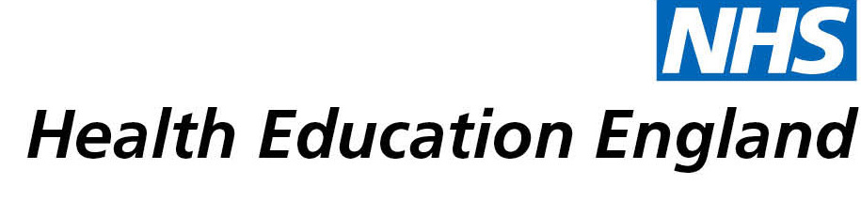

# Library and Knowledge Services case study

# Gloucestershire Hospitals NHS Foundation Trust: Introduction of ACEs Screening

5 May 2021

## Reason for enquiry

## More information was required about Adverse Childhood Experiences (ACES) and it’s impact in maternity/neonatal services and the effects of parental ACEs on health and wellbeing of the newborn/neonate. This was required as part of a Quality Improvement project to introduce ACEs screening into the maternity booking process in order to better identify risk, promote resilience and improve parenting capacity, plus assist with a publication.

## What the knowledge and library specialist did

Claire O’Connor, Deputy Library & Knowledge Services Manager conducted a synthesised Evidence Search. An evidence search is when the best and most appropriate information is found by a librarian using range of searching techniques and resources. The information is then summarised and presented in a format which makes it easier and quicker for the clinician to read.

A range of specialist research databases were searched including Embase, Cinahl and PsycInfo. A general scoping search of the internet was also conducted.

A variety of research and reports were found from the UK and wider afield. The evidence was summarised and organised by theme including evidence on screening and effects of ACEs on parents.

# Impact of input from the library and knowledge service

Due to the work of the Library & Knowledge Service, clinical time was saved and enabled the sharing of knowledge though the successful publication of a journal article. The evidence found will help to expand the use of ACEs within the midwifery team and in the long term reduce risk to children

## Immediate Impact

The work the Library & Knowledge Service did and the evidence Claire found **“Enabled submission of [the] project to BJM [British Journal of Midwifery] and their subsequent acceptance”. The service also saved “hours of trawling search sites to locate relevant articles.”**

## Probable future Impact

**“Relaunching project in bigger team within midwifery, likely to expand further and hopefully will reduce risk to children ultimately.”**

## Submission by:

Michelle Richardson

Senior Sister – Neonatal Unit, Gloucestershire Royal Hospital

## For further information on how you can get similar support contact your local NHS library and knowledge service.